<https://dotnet.microsoft.com/en-us/download/visual-studio-sdks?cid=msbuild-developerpacks>

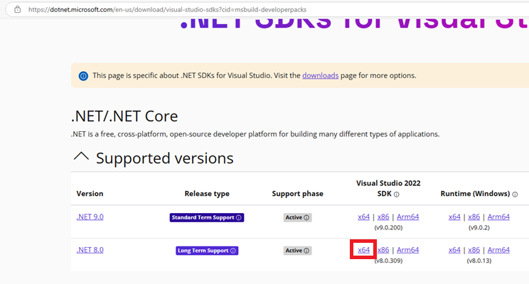

<https://visualstudio.microsoft.com/downloads/>

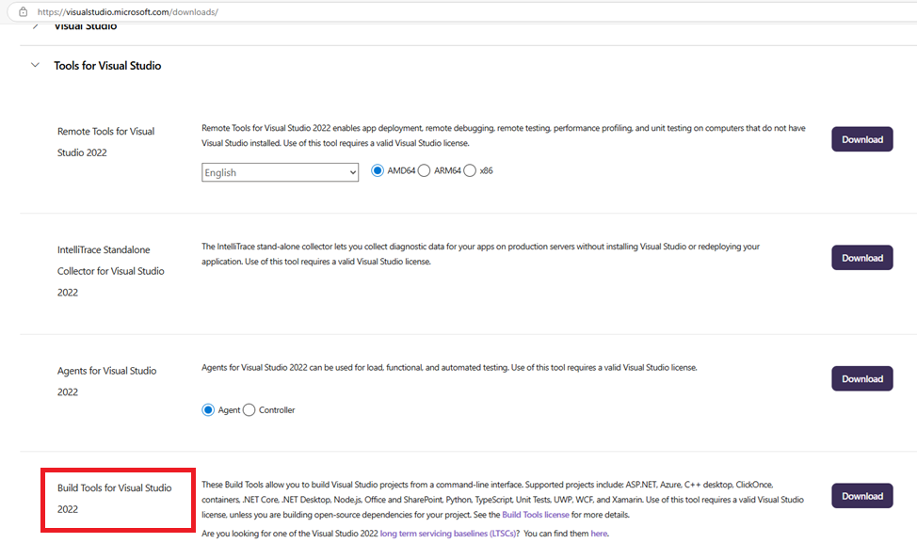

<https://dotnet.microsoft.com/en-us/download/dotnet/8.0>

<https://learn.microsoft.com/en-us/cli/azure/install-azure-cli-windows?pivots=msi>

